**ASSIGNMENT 4**

1. ODD STRING DIFFERENCE :

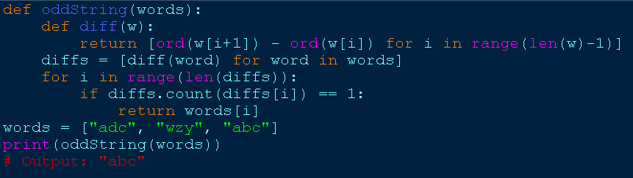

1. WORDS WITHIN TWO EDITS OF DICTIONARY :

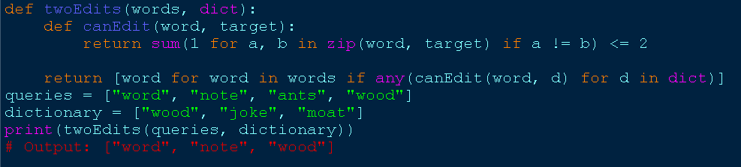

1. NEXT GREATER ELEMENT IV :

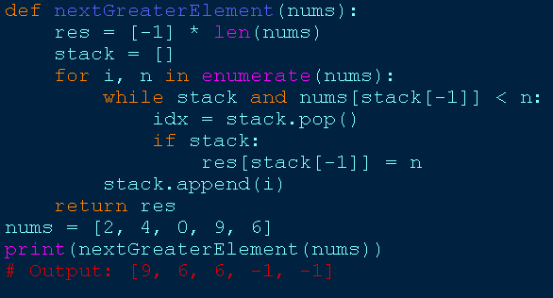

1. MINIMUM ADDITION TO MAKE INTEGER BEAUTIFUL :

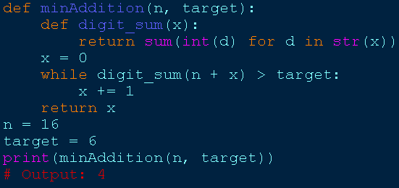

1. SORT ARRAY BY MOVING ITEMS TO EMPTY SPACES :

